**SYST10199: Assignment 4**

*© Sheridan College*

**1. The Tim Horton’s App**

* Make an app that implements the behavior in the storyboards below.
* The first page is index.html but the second page must be a PHP file.
* Use POST rather than GET to send parameters.
* Use the images posted on SLATE
* Resize the cup image in HTML/CSS to show the different sizes.
* Style the pages at least a little bit by linking them both to the same CSS style sheet.

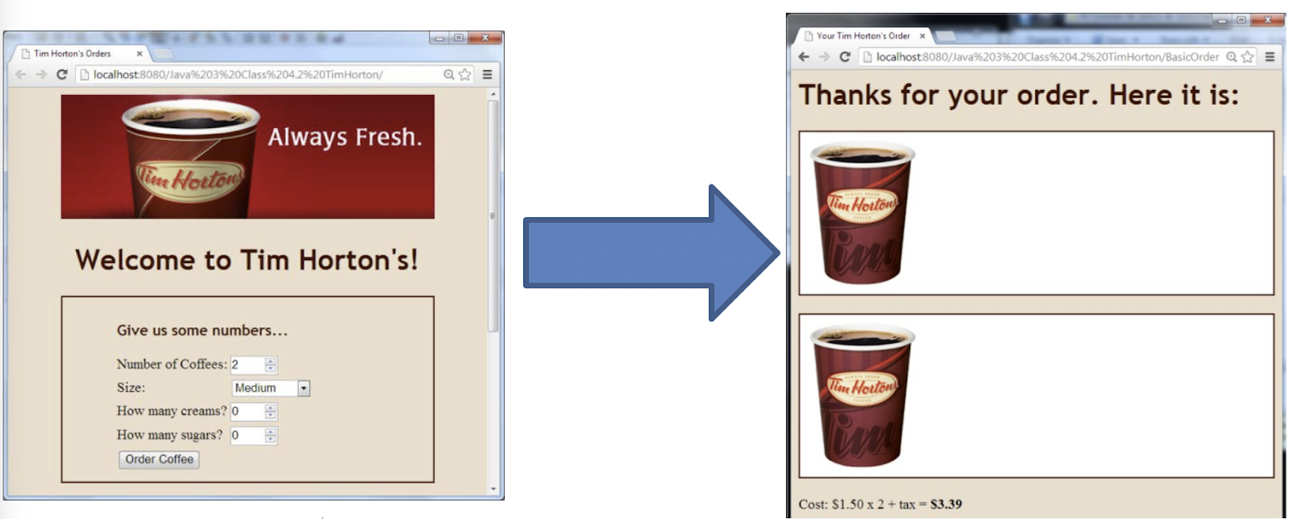

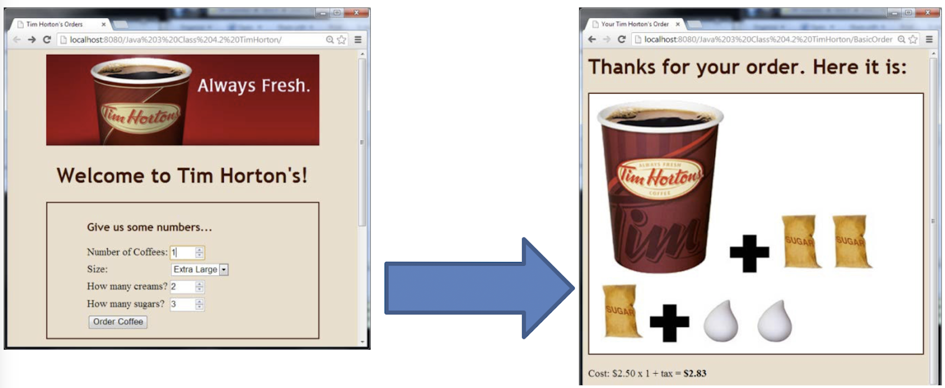

**2. The Slang Version**

* Update your app to allow the user the choice of ordering with “slang” in a second form as shown below.
* Your app should give the same correct output.
* On the output end, you can view this as a translation problem.
  + Translating from a slang term like “Double Double” to numbers that represent the number of sugars and creams.
  + On the other hand,  maybe there’s a way to set up the form so that it still sends sugar and cream info rather than slang terms…

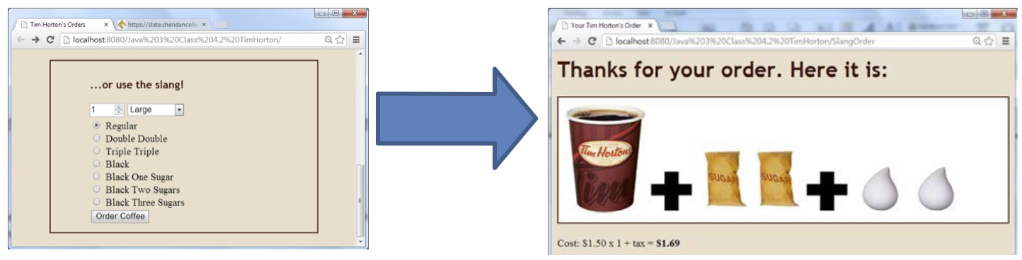

**3. File organization & setup**

* Your form should be called “index.html” and should be in a folder called “tims”.
* CSS should be in a separate file.
* The main folder should have subfolders for css and images.